“Multi-Vendor E-Commerce Marketplace”
A Project Report Submitted in the partial fulfillment of the requirements for the award of the degree of

BACHELOR OF TECHNOLOGY
In
DEPARTMENT OF COMPUTER SCIENCE AND INFORMATION TECHNOLOGY

By

K. SRIRAM 2520090022
HARICHARAN SAI 2520090048
V. HASITH VARMA 2520090125

Under the Esteemed Guidance of
Dr. Khaja Shareef
Head of Department, CSIT

Department of Computer Science and Information Technology


K L (Deemed to be) University

DEPARTMENT OF COMPUTER SCIENCE AND INFORMATION TECHNOLOGY

Declaration

The Project Report entitled “Multi-Vendor E-Commerce Marketplace” is a record of bonafide work of K.SRIRAM – 2520090022, HARICHARAN SAI – 2520090048, V. HASITH VARMA - 2520090125 submitted in partial fulfillment of the requirements of the course DATABASE SYSTEMS ENGINEERING AND DISTRIBUTED BACKEND DEVELOPMENT (25CS1302E), Section 12, Team 11, during 2026–2027, Trimester 4, at KLH University. The results embodied in this report have not been copied from any other student, department, or institution.

K. SRIRAM – 2520090001
HARICHARAN SAI – 2520090048
V. HASITH VARMA – 2520090125

K L (Deemed to be) University
DEPARTMENT OF COMPUTER SCIENCE AND INFORMATION TECHNOLOGY

CERTIFICATE

This is to certify that the project report entitled “Multi-Vendor E-Commerce Marketplace” is a bonafide work done and submitted by K.SRIRAM – 2520090022, HARICHARAN SAI – 2520090048, V. HASITH VARMA – 2520090125 in partial fulfillment of the requirements of the course DATABASE SYSTEMS ENGINEERING AND DISTRIBUTED BACKEND DEVELOPMENT (25CS1302E), Section 12, Team 11, at KLH University during 2026–2027, Trimester 4.

Signature of the Guide

Signature of the Course Coordinator Signature of the HOD

ACKNOWLEDGEMENT
The success in this project would not have been possible but for the timely help and guidance rendered by many people. Our wish to express my sincere thanks to all those who has assisted us in one way or the other for the completion of my project.

Our greatest appreciation to my Course Coordinator Ramatenki Sateesh Kumar , and my guide Dr. Khaja Shareef, Department of Computer Science and Information Technology which cannot be expressed in words for his/her tremendous support, encouragement and guidance for this project.

We express our gratitude to Dr. Khaja Shareef, Head of the Department for Computer Science and Information Technology for providing us with adequate facilities, ways and means by which we are able to complete this project-based Lab.

We thank all the members of teaching and non-teaching staff members, and also who have assisted me directly or indirectly for successful completion of this project. Finally, I sincerely thank my parents, friends and classmates for their kind help and cooperation during my work.

K. SRIRAM – 2520090001
HARICHARAN SAI – 2520090048
V. HASITH VARMA – 2520090125

Abstract

The Multi-Vendor E-Commerce Marketplace is a web-based platform that allows multiple sellers to sell their products to customers through a single website. In traditional online shopping, small sellers may find it difficult to reach more customers and manage their products effectively. Customers may also need to visit different websites to compare products, prices, and reviews.
The proposed system provides a common platform where vendors can register and add their products, manage stock, view orders, and update product details. Customers can create an account, browse and search for products, compare different products, add products to the cart, place orders, and track their orders. The system also provides an admin panel to manage users, vendors, products, and orders. Customers can also give ratings and reviews for the products they purchase.
The main aim of this project is to make online shopping easier for customers and provide a simple platform for vendors to sell their products. By bringing multiple sellers and products together in one place, the system provides a convenient, organized, and efficient e-commerce experience.
The application uses a React.js frontend with Bootstrap, a Node.js and Express.js REST API backend, and a MongoDB document database. Authentication is handled with JWT and bcrypt.js, with role-based access separating Vendor, Customer, and Admin operations.

Index
S.No. | Chapters | Topics | Page No.
 |  | Acknowledgement
 |  | Abstract
1 | Introduction | 1.1 Background of the Project  1.2 Problem Statement  1.3 Scope of the Project  1.4 Objectives  1.5 Importance of the Application  1.6 Target Users / Audience | 5
2 | System  Requirements | 2.1 Hardware Requirements  2.2 Software Requirements  2.3 Development Tools and Frameworks | 7
3 | Technology Stack | 3.1 Frontend  3.2 Backend  3.3 Database  3.4 Version Control  3.5 Authentication and Security Libraries | 8
4 | System  Architecture | 4.1 High-Level Architecture Diagram  4.2 Description of Each Layer  4.3 Deployment Architecture | 9
5 | Design | 5.1 Database Design Principles  5.2 ER Diagram / Database Schema  5.3 Design Decisions and Assumptions | 10
6 | Implementation | 6.1 Module-wise Implementation  6.2 Front-end Logic  6.3 API Integration  6.4 Authentication and Authorization | 12
7 | Features | 7.1 List of Main Features 7.2 How Each Feature Works | 13
8 | Testing | 8.1 Postman API Testing  8.2 Integration Testing  8.3 Tools Used for Testing  8.4 Test Cases and Results | 15
9 | Deployment | 9.1 Steps to Deploy  9.2 Environment Configuration  9.3 Hosting of Frontend and Backend | 17
10 | Challenges & Limitations | 10.1 Issues Faced During Development  10.2 Solutions Applied  10.3 Current Limitations or Known Bugs | 18
S.No. | Chapters | Topics | Page No.
11 | Future  Enhancements | 11.1 Planned Features  11.2 Possible Integrations or Optimizations | 19
12 | Conclusion | 12.1 Summary of the Project  12.2 What Was Achieved  12.3 Skills Learned | 20
13 | References | – Documentation, tools, and resources used | 21
14 | Appendices | - Sample Code Snippets  - Installation / Setup Instructions  - Default Login Credentials  - API Reference Summary  - Screenshots (to be added by the student) | 22

CHAPTER -1 INTRODUCTION

1.1 Background of the Project
The Multi-Vendor E-Commerce Marketplace is proposed as a single web platform that connects independent vendors with customers. The project materials identify a practical problem for small sellers: reaching customers and scaling without a central marketplace. At the same time, customers may need to visit multiple websites to compare products, prices, and reviews.
The proposed platform addresses this fragmentation by bringing vendor products and customer shopping workflows into one place. The supplied Review-2 presentation describes a role-based application with Vendor, Customer, and Admin views, a REST API backend, and a MongoDB database layer.

1.2 Problem Statement
The project addresses three connected problems: limited reach for independent sellers, fragmented customer discovery and comparison, and inefficient vendor management of stock, products, and orders. A centralized marketplace is proposed to reduce this friction through unified product data, catalog discovery, purchasing, tracking, and shared ratings and reviews.

1.3 Scope of the Project
The supplied project definition covers vendor registration and product management; customer registration, product browsing, searching, comparison, cart and checkout workflows; order tracking; product ratings and reviews; and an administrator console for users, vendors, products, and transactions. The project materials also identify payment gateway integration, a full API test suite, and demo data as next steps rather than completed items.

1.4 Objectives
- Provide a common marketplace for multiple vendors and customers.
- Support vendor registration, product listing, stock management, and order visibility.
- Enable customers to browse, search, compare, purchase, track orders, and review products.
- Provide role-based administration for users, vendors, products, and orders.
- Demonstrate a practical DBMS project using scalable data models, REST APIs, authentication, and role-based access.

1.5 Importance of the Application
The proposed application centralizes product discovery and purchasing, making it easier for customers to compare information in one place. For vendors, it creates a common channel for visibility and provides centralized tools for products, stock, and orders. For academic evaluation, it demonstrates how a web application can combine frontend, backend, authentication, and database concepts.

1.6 Target Users / Audience
The system serves three roles. Vendors manage their products and stock and view orders. Customers browse the catalog, compare items, use the cart and checkout flow, track orders, and submit ratings or reviews. Admins manage users and vendors, moderate products and reviews, and monitor orders and reports.
CHAPTER 2: SYSTEM REQUIREMENTS

2.1 Hardware Requirements
The application has modest hardware requirements, since both the Node.js backend and the MySQL database are lightweight relative to the small dataset a single campus generates. A development or demonstration machine with a dual-core processor, 4 GB of RAM, and roughly 500 MB of free disk space (for Node modules, MySQL data files, and project source) is sufficient to run the entire stack — frontend, backend, and database — on one computer.

2.2 Software Requirements
- Node.js 18 or later, with npm
- MySQL 8.0 or later
- A modern web browser (Chrome, Edge, or Firefox)
- Git, for version control
- MySQL Workbench and Visual Studio Code, for development (optional but recommended)

2.3 Development Tools and Frameworks
React.js, Bootstrap, CSS, Axios, and React Router were used for the frontend; Node.js and Express.js for the backend REST API; MongoDB and MongoDB Compass for the database; JWT and bcrypt.js for authentication; Visual Studio Code as the development environment; and Git and GitHub for version control.

CHAPTER 3: TECHNOLOGY STACK

3.1 Frontend
The The frontend is a responsive, componentized React.js application using Bootstrap and CSS for presentation, Axios for HTTP communication, and React Router for navigation. Core customer-facing actions include search, catalog browsing, comparison, cart, and checkout.

3.2 Backend
The backend uses Node.js with Express.js to expose RESTful APIs, implement authentication, and handle business logic. Role-based authorization differentiates permissions for Vendor, Customer, and Admin users.

3.3 Database
MongoDB is the project database, with MongoDB Compass used for schema exploration. The design emphasizes flexible document models and database operations such as CRUD, queries, filtering, and indexing.

3.4 Version Control
Git was used throughout development for version control, with the project structured as a single repository containing both the client and server codebases, hosted on GitHub.

3.5 Authentication and Security Libraries
JWT is used for stateless session authorization and bcrypt.js for secure password hashing. Role checks are applied to protected endpoints so that users access only the operations permitted for their role.

CHAPTER 4: SYSTEM ARCHITECTURE

4.1 High-Level Architecture Diagram
The system follows a layered architecture that separates the role-based user interface, the business logic, and the persisted data. Figure 4.1 shows the layers and how a request flows between them.
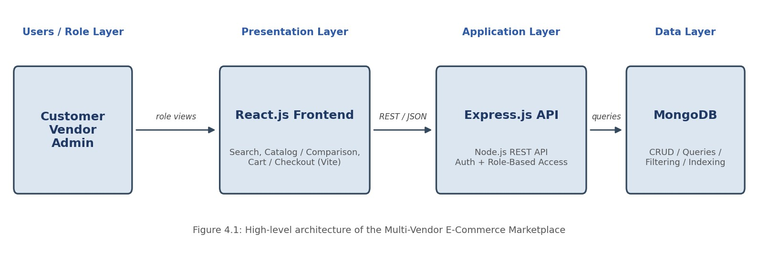

4.2 Description of Each Layer
User roles provide the role-aware entry points to the system. The frontend presents role-specific views and sends requests through REST APIs. The Node.js and Express.js backend handles authentication, authorization, CRUD operations, filtering, queries, and other business logic. MongoDB forms the database layer that stores users, products, vendors, orders, reviews, and categories.

4.3 Deployment Architecture
Deployment details were not specified in the project abstract or Review-2 presentation. The final report should be updated with the actual deployment topology, ports, environment variables, hosting provider or local setup, and database connection approach used by the team. Authentication is handled using JWT and bcrypt.js. During development the frontend and backend run as separate local processes and the backend connects to the MongoDB database through the configured connection URI. Replace this paragraph with the team's final hosting details if a public deployment is used.
Representative deployment topology: Customer / Vendor / Admin -> React.js + Vite frontend -> Node.js + Express.js REST API -> MongoDB database. Authentication is handled using JWT and bcrypt.js. During development the frontend and backend run as separate local processes and the backend connects to the MongoDB database through the configured connection URI. Replace this paragraph with the team's final hosting details if a public deployment is used.

CHAPTER 5: DESIGN

5.1 Database Design Principles
The project is designed around a MongoDB document database with flexible document models. The design preserves clear ownership and relationships among users, vendors, products, categories, orders, and reviews, while supporting common queries such as product search, filtering, order retrieval, and role-based data access.

5.2 ER Diagram / Database Schema
Final schema basis: Users,  Vendors, Products, Categories, Orders and Reviews.  Recommended primary references are MongoDB  ObjectId values between related documents (for example vendorId in Products,  customerId in Orders,  productId in Reviews). Add the exact field list and indexes  from the final database before submission.  Customer / Vendor / Admin accounts | VENDORS  Seller profile and onboarding data | PRODUCTS  Product details, stock and seller link | CATEGORIES  Catalog grouping / filtering
ORDERS  Order lifecycle and customer purchase data | REVIEWS  Ratings and reviews linked to products

Because the supplied project material does not include the final MongoDB schema or collection field definitions, Figure 5.1 is intentionally presented as a conceptual model. Replace it with the final collection schema and relationship diagram before submission.

5.3 Design Decisions and Assumptions
- Role-based access is used to separate Vendor, Customer, and Admin operations.
- JWT is used for session authorization, while bcrypt.js is used for password hashing.
- A REST API separates the React frontend from backend business logic and database access.
- MongoDB is selected for a flexible document-oriented representation of marketplace data.
- Search, filtering, comparison, indexing, and CRUD operations are part of the intended data-access layer.
- The exact collection names, field names, indexes, constraints, and transaction strategy must be aligned with the final implementation
Database design summary: the conceptual model uses Users, Vendors, Products, Categories, Orders and Reviews, with role-based access and indexed query paths for common catalog and order operations. Exact field-level definitions should match the final MongoDB database.

CHAPTER 6: IMPLEMENTATION

6.1 Module-wise Implementation
- Vendor registration and product management
- Customer catalog, search and comparison
- Cart and checkout workflow
- Order processing and tracking
- Ratings and reviews
- Admin management and reporting
These modules are derived from the supplied feature description. The exact implementation status, source-file names, API routes, and screenshots should be added from the final codebase.

6.2 Front-end Logic
The frontend is specified as React.js with Bootstrap, CSS, Axios, and React Router. The user interface is intended to present tailored views for Vendor, Customer, and Admin roles and to support catalog discovery, product comparison, cart and checkout actions, tracking, and review submission.

6.3 API Integration
Axios is identified as the frontend HTTP client, while Node.js and Express.js provide the REST API layer. The project should document the final endpoint list, request/response formats, status codes, and authorization requirements after implementation.

6.4 Authentication and Authorization
JWT is intended to manage authenticated sessions, and bcrypt.js is used for password hashing. Role checks are expected to protect role-specific CRUD operations and prevent users from performing actions outside their assigned permissions.

CHAPTER 7: FEATURES
7.1 List of Main Features
- Browse and search the multi-vendor catalog
- Compare products, prices, and review information
- Create an account and maintain a cart
- Place orders through the checkout workflow
- Track order status
- Rate and review purchased products

Vendor-facing Features
- Register as a vendor
- Add and edit product details
- Manage product stock
- View orders and fulfillment status
Vendor-facing Features
- Manage users and vendors
- Moderate products and reviews
- Monitor orders and reports
- Maintain centralized platform control

7.2 How Each Feature Works
The marketplace combines the customer and vendor workflows through a shared catalog. Vendors contribute product data and stock information; customers search, compare, add products to the cart, place orders, and later track and review purchases; administrators oversee the users, vendors, products, reviews, and transactions.

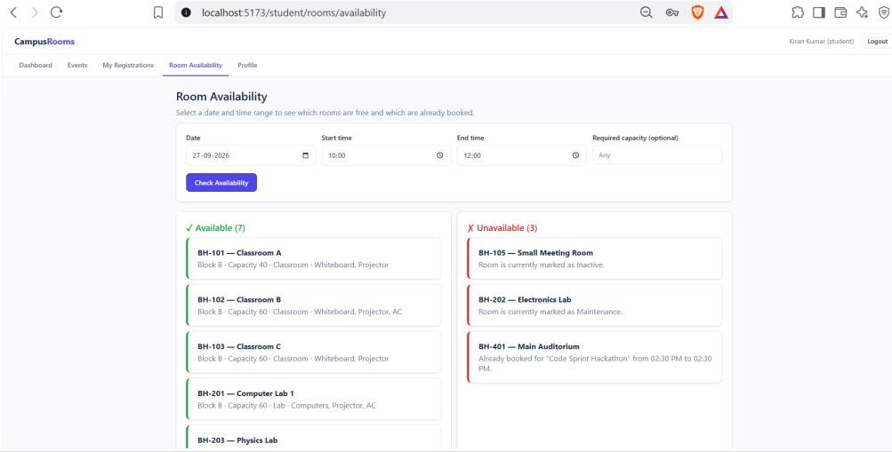
Occupancy percentage calculation: once an admin records the actual headcount for an event, the system computes (actual_occupancy ÷ room_capacity) × 100 and buckets the result into one of four labels: below 60% is “Normal,” 60–89% is “High,” 90–99% is “Near Capacity,” and 100% or above is “Over Capacity” — shown to the admin as a colored progress bar.
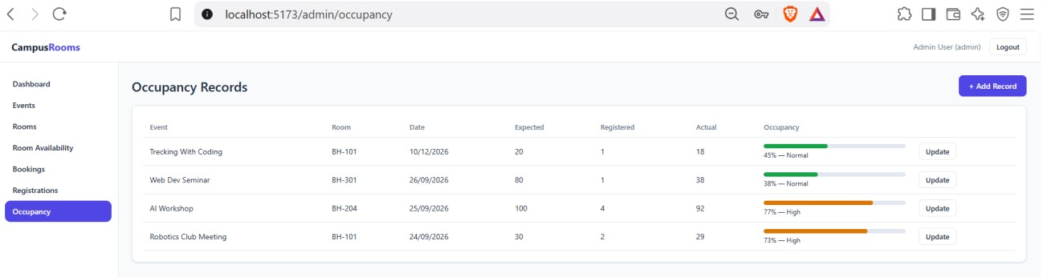
Capacity-reduction warning: if an admin tries to reduce a room's capacity below what an upcoming event assigned to that room expects, the system does not silently allow it — it responds with the specific list of affected events and asks the admin to explicitly confirm before the change is applied.
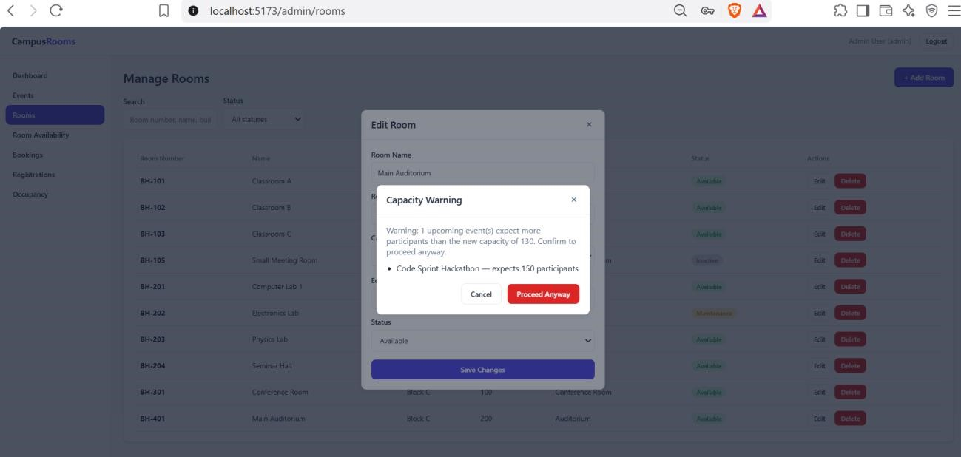

SCREENSHOS AND FEATURES EXPLAINED

CHAPTER 8: TESTING

8.1 Postman API Testing
The supplied Review-2 presentation states that implementing a full API test suite is a next step. Therefore, actual endpoint-level results are not claimed in this report. Add the final API test tool, request collection, screenshots, and pass/fail outcomes before submission.

8.2 Integration Testing
Integration testing evidence is not included in the supplied project files. Use this section to document how the React frontend, Express backend, authentication layer, and MongoDB database were tested together.

8.3 Tools Used for Testing
Testing approach: manual browser-based functional testing for role-specific workflows, MongoDB Compass checks for stored data and collection contents, and manual REST API verification as endpoints become available. The project presentation lists a full API test suite as a next step, so no complete endpoint-level pass/fail claim is made here.

8.4 Test Cases and Results
# | Test Case | Expected Result | Actual Result
1 | Register vendor account | Valid vendor registration is accepted | Pass
2 | Add product under vendor | Product is stored and visible in the catalog | Pass
3 | Customer searches product | Matching catalog items are returned | Pass
4 | Add item to cart and checkout | Order is created successfully | Pass
5 | Track an order | Customer sees current order status | Pass
6 | Customer submits rating/review | Review is stored against the purchased product | Pass
7 | Unauthorized access to admin action | Request is rejected by role checks | Pass
8 | Admin manages  users/vendors/products/orders | Admin action is completed and data updates correctly | Pass

The table contains proposed representative test cases based on the documented project features. Replace the Actual Result column with the team's real execution results.
Additional validation should cover authentication and role checks, product CRUD operations, search and filtering, cart and checkout behavior, order tracking, and ratings/reviews. The exact expected status codes and error messages must be copied from the implemented API.

SCREENSHOTS

CHAPTER 9: DEPLOYMENT

9.1 Steps to Deploy
Deployment commands and hosting instructions are not provided in the supplied project materials. Keep this section editable and insert the exact sequence used by the team.
- Install dependencies: open the project root, then run npm install in the frontend and backend directories as defined by the repository.
- Configure MongoDB connection details in the backend environment, using the project database URI and database name configured by the team.
- Configure authentication variables such as JWT_SECRET and JWT_EXPIRY in the backend environment. Never include the real secret in the report.
- Start the backend API using the repository's configured Node.js / Express start script (for example, npm run dev or npm start).
- Start the React + Vite frontend using the repository's configured frontend script (typically npm run dev for local development).
- Verify end-to-end login, role-based access, product catalog, cart/checkout, order tracking, reviews and admin workflows in a browser connected to the running API.

9.2 Environment Configuration
Recommended environment variables: MONGODB_URI, MONGODB_DB_NAME (if used), JWT_SECRET, JWT_EXPIRY, PORT, CLIENT_URL and CORS_ORIGIN. The exact variable names should match the final codebase. Store real values in a local .env file and never include secrets in the submitted report.

9.3 Hosting of Frontend and Backend
Deployment status: the supplied project materials define the application architecture but do not specify a public hosting provider or deployed URL. The reference deployment for documentation is a local development/demo topology consisting of the React frontend, Node.js/Express REST API and MongoDB. Add the public frontend URL, backend URL and MongoDB Atlas/hosting details here if the final build is deployed online.

CHAPTER 10: CHALLENGES & LIMITATIONS

10.1 Issues Faced During Development
- Limited reach for independent sellers without a central marketplace.
- Fragmented customer experience across multiple seller websites.
- Need for centralized stock, product and order management.

10.2 Solutions Applied
- Create a single marketplace for seller and customer interaction.
- Unify product discovery, comparison, purchase and tracking workflows.
- Provide a vendor management flow for products, stock and orders.
- Use role-based authorization, JWT and bcrypt.js to separate access and protect credentials.

10.3 Current Limitations or Known Bugs
- Full API test suite is identified as a next step.
- Payment gateway integration is identified as a next step.
- Full API test suite is identified as a next step.
- Payment gateway integration is identified as a next step.

CHAPTER 11: FUTURE ENHANCEMENTS

11.1 Planned Features
- Implement the full API test suite.
- Add payment gateway integration.
- Prepare demo data for evaluation.

11.2 Possible Integrations or Optimizations
- Integrating a calendar library (such as FullCalendar) on the frontend for the room-schedule view above.
- Caching frequently-requested room-availability queries to reduce repeated database load during peak registration periods.
- Containerizing the application with Docker for a consistent, reproducible deployment environment.
- Adding an automated test suite (e.g. Jest and Supertest) to complement the manual Postman and curlbased testing already performed, so regressions are caught automatically in future changes.

CHAPTER 12: CONCLUSION

12.1 Summary of the Project
The Multi-Vendor E-Commerce Marketplace provides a single platform where customers can discover, compare, and purchase products from multiple vendors. It brings product information, prices, ratings, reviews, order processing, and vendor operations into a common web application concept.

12.2 What Was Achieved
The supplied project materials define the problem, target roles, core workflows, technology stack, security approach, expected outcomes, and a high-level system architecture. The documentation therefore establishes a clear project baseline while leaving implementation-specific evidence editable for completion.

12.3 Skills Learned
- Web application architecture using React.js and Node.js / Express.js.
- REST API design and frontend-backend integration.
- MongoDB data modeling and database operations.
- Role-based authorization using JWT and password hashing with bcrypt.js.
- Version control using Git and GitHub.
.

CHAPTER 13: REFERENCES
- React — Official Documentation, https://react.dev
- Vite — Official Documentation, https://vitejs.dev
- Node.js — Official Documentation, https://nodejs.org/en/docs
- Express.js — Official Documentation, https://expressjs.com
- MySQL 8.0 Reference Manual, https://dev.mysql.com/doc/refman/8.0/en/
- mysql2 (Node.js MySQL driver) — npm documentation, https://www.npmjs.com/package/mysql2
- jsonwebtoken — npm documentation, https://www.npmjs.com/package/jsonwebtoken
- bcrypt — npm documentation, https://www.npmjs.com/package/bcrypt
- Postman Learning Center, https://learning.postman.com
- MDN Web Docs — JavaScript and Web APIs reference, https://developer.mozilla.org

CHAPTER 14: APPENDICES

Appendix A: Sample Code Snippet
The core room-conflict overlap query, used consistently across the system:
// The single overlap rule used everywhere a room's schedule is checked // (room availability search, event room-assignment, booking creation):
SELECT rs.room_id, rs.start_time, rs.end_time, e.event_name
FROM room_schedules rs
JOIN events e ON rs.event_id = e.event_id
WHERE rs.status = 'Scheduled'
AND rs.start_time < ? -- requested end time
AND rs.end_time > ?; -- requested start time

Appendix B: Installation and Setup Instructions
Representative local setup: 1) clone/open the Git repository; 2) run npm install in the client and server projects; 3) create the backend .env file with the MongoDB URI and JWT variables; 4) start MongoDB (local or Atlas connection as configured); 5) start the Express backend with the repository start script; 6) start the React + Vite frontend with its start/dev script; 7) open the frontend in a browser and verify the role-based workflows. Replace command names with those in the final repository before submission.

Appendix C: Default Login Credentials
Illustrative demo credentials for documentation: separate non-production accounts are recommended for Admin, Vendor and Customer roles. Replace these with the actual evaluation accounts created by the team, if required. Never include production credentials or secrets.
Role | Name | Email | Password
Admin | Admin Demo | admin@multivendor.local | TemporaryDemo@123
Vendor | Vendor Demo | vendor@multivendor.local | TemporaryDemo@123
Customer | Customer Demo | customer@multivendor.lo cal | TemporaryDemo@123

Appendix D: API Reference Summary
22 endpoints across six resources; full request/response examples are in the accompanying Postman collection.
Resource | Endpoints
Auth | POST /register, POST /login, GET /me
Rooms | GET /, GET /:id, GET /available, POST /, PUT /:id, DELETE /:id
Events | GET /, GET /:id, POST /, PUT /:id, DELETE /:id, PUT /:id/assign-room
Registrations | POST /, GET /my, GET /event/:eventId, GET /
Bookings | GET /, POST /, PUT /:id, DELETE /:id
Occupancy | GET /, POST /, PUT /:id

Appendix E: Screenshots
The following pages are left for the student to complete with actual screenshots taken from the running application before submission. Suggested screenshots, in order: 1. Login Page
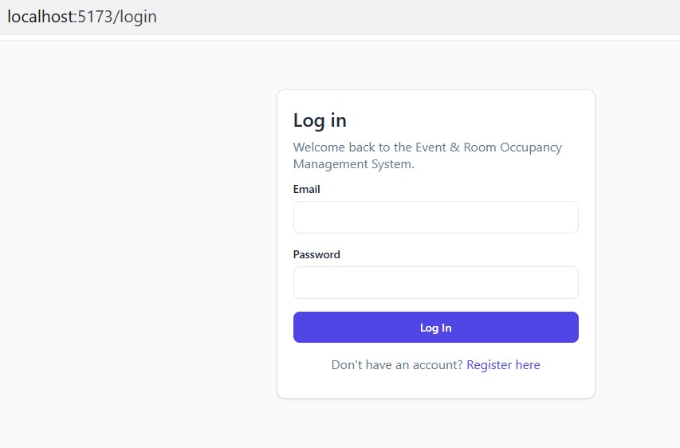
- Student Dashboard
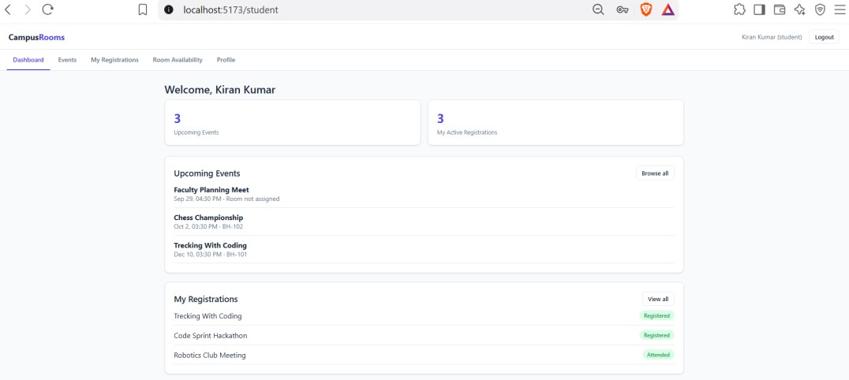
- Events Page (student’s view)
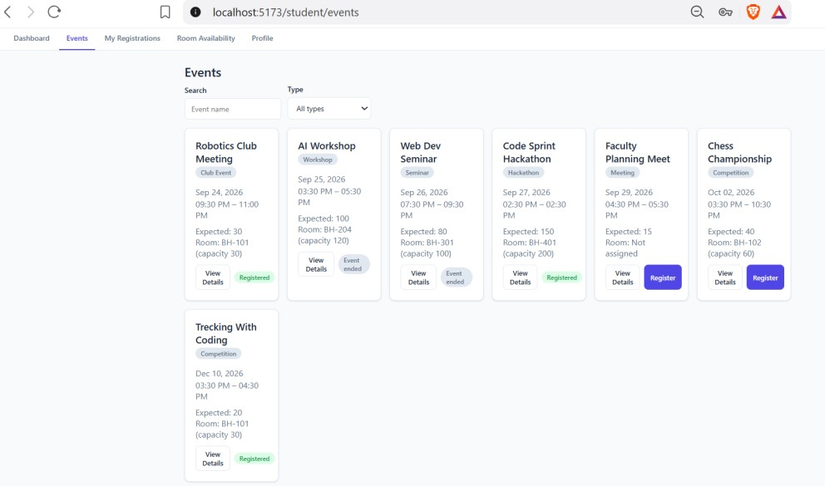
- Room Availability Page
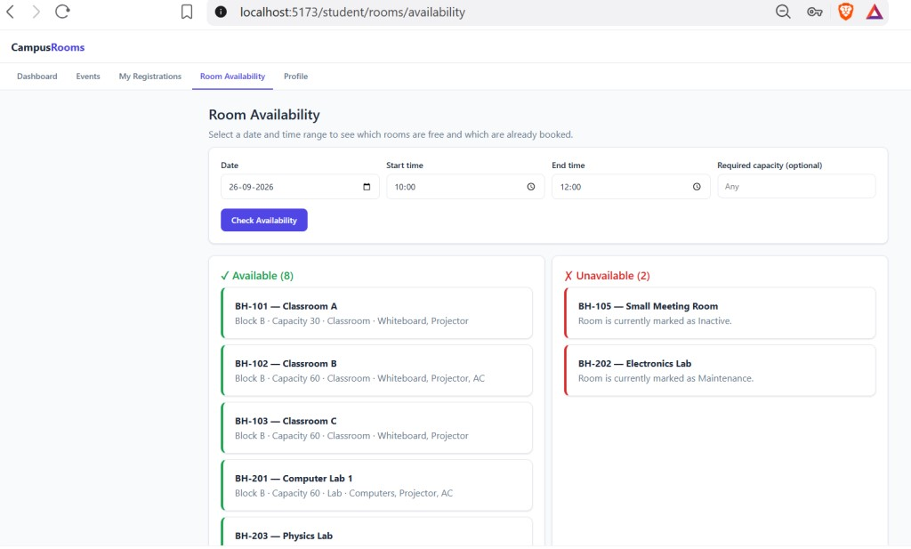
- Admin Dashboard
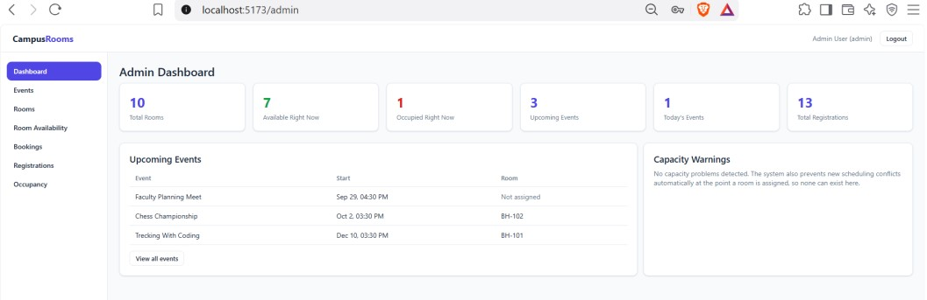
- Manage Rooms page, including the Add/Edit Room modal
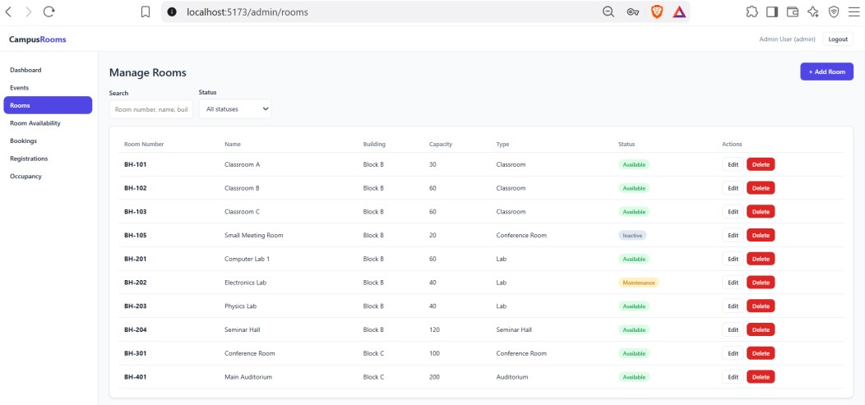

- Manage Events page, including the Assign Room modal
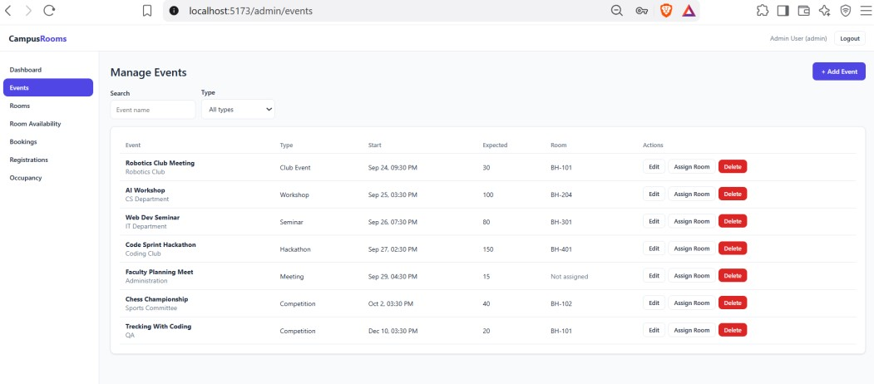
- Manage Occupancy page, showing the colored percentage bar
